Calculus 3
Problem Set #1~ Spring 2025

Scoring Rubric: Points are awarded according to the following guidelines.

- 4 points may be awarded for a response that includes a perfect answer with all major steps shown that leads to the answer. Minor calculations may be omitted.

- 3 points may be awarded for a response that includes a incorrect answer due to a minor miscalculation where the correct method is used. Alternatively, 3 points may be awarded for a correct answer that omits a major step.

- 2 points may be awarded for a response that includes an incorrect answer given due to a major mathematical error in calculation. Alternatively, 2 points may be awarded for
an answer that omits several major steps. Another scenario that may lead to 2 points being awarded is one where an answer is provided but the method used is not the one that is specified in the problem. Note: An incorrectly placed negative or positive sign is not necessarily a minor error; it could be a major error.

- 1 point may be awarded for a very minimal response that references a correct method. i.e. a response that references a correct theorem but does not provide any details as to how a solution may be obtained. Alternatively, 1 point may be awarded for a response that includes only a correct answer with no or very few key steps shown.

- 0 points are awarded for a completely incorrect response.

- Given the points (3, 8, 1), (1, 1, 1) and (x, 5, 6) where x is a real number. Compute a value of x such that the points form a right triangle.

- Consider the vectors 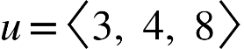 and 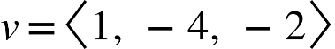

Determine if u ✕ v is orthogonal to both u and v by computing
u · (u ✕ v)

- The vectors u = 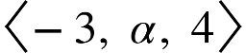 and v = 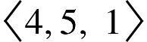 are orthogonal. Determine the value of . Once is determined. Compute a third vector that is orthogonal to both u and v. Is your vector the only vector that is orthogonal to both u and v? Why or why not?

- Find a set of parametric equations of the line with the given characteristics. The line passes through the point (-3, 5, 7) and is parallel to the xz-plane and the yz-plane.

- Find a set of parametric equations of the line with the given characteristics.
The line passes through the point (5, 2, -6) and is parallel to v = 3i −4 j.

- Find the equation of a plane that passes through the points (3, 4, 5), (-2, -9, 0)
and (4, 4, 3).

- Find two vectors that are normal to the plane 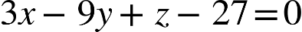

- Verify that the point (3, 1, 27) is on the plane: . Once the point is verified to be on the plane. Find a vector that passes through (3, 1, 27) and is orthogonal to the plane.

- Find the domain of the vector valued function: 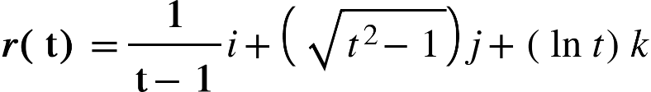

- Compute the derivative, 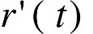of the vector valued function from #9.

- Compute the domain of from #10.

